PW SKILLS ASSIGNMENT 4
EASY LEVEL:
Q1. What is the purpose of a PivotTable in Excel?
Ans1: PivotTable in Excel is used to summarize the data and analyze the datasets and organize the large datasets.
Q2. Create a Pivot Table to show Total Sales by Region.
Ans2.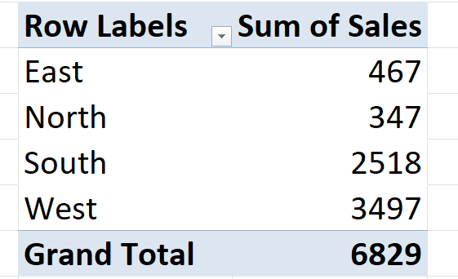
Q3. Apply Conditional Formatting to highlight sales greater than 400.
Ans3.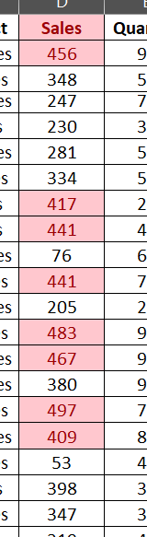
Medium Level
Q4. Explain the difference between Sorting and Filtering with an example from this dataset.
Ans4. Sorting: It is used to arrange the data into the order from Smallest to Largest, Largest to Smallest or arranging in Alphabetical order A-Z, a-z.
Example: 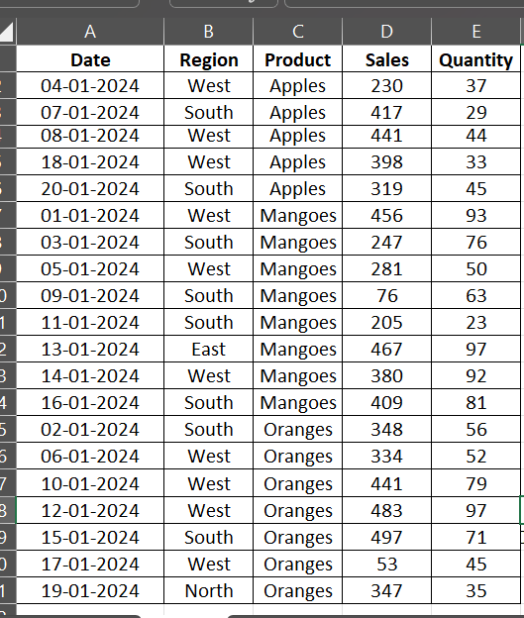
Here we did sorting in alphabetical order in Product from A-Z.
Filtering: It is used to filter the data only required data is shown.
Example: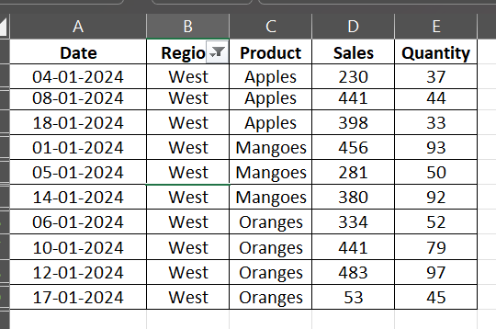
Here we did filtering on the basis of Region we choose only West to show data of west region only.
Q5. Create a PivotChart showing Monthly Sales Trend.
Ans: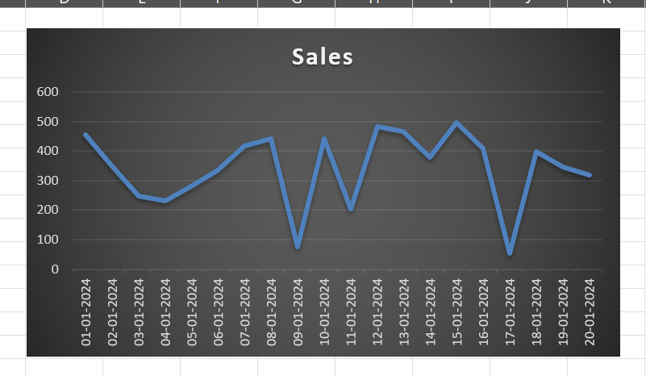
Q6. Use a Slicer to filter data by Product and observe changes in sales.

HARD LEVEL
Q7. Why are Dashboards important for decision-making in business analysis?
ANS: Dashboards are important for decision-making in business analysis because it will the to find out the insights where the sales increases and decreases. It also let us know about the status of the business through Charts, graphs, KPIs etc.
Q8. Create a Dashboard that includes:
Sales by Region (PivotTable + Chart)
Product Filter (Slicer)
Monthly Trend (Line Chart)
ANS:

DASHBOARD
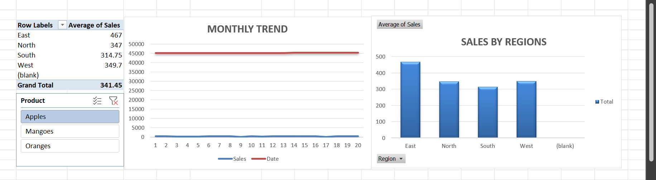
Q9. Group dates in the PivotTable into Months and calculate the average sales per month.
ANS: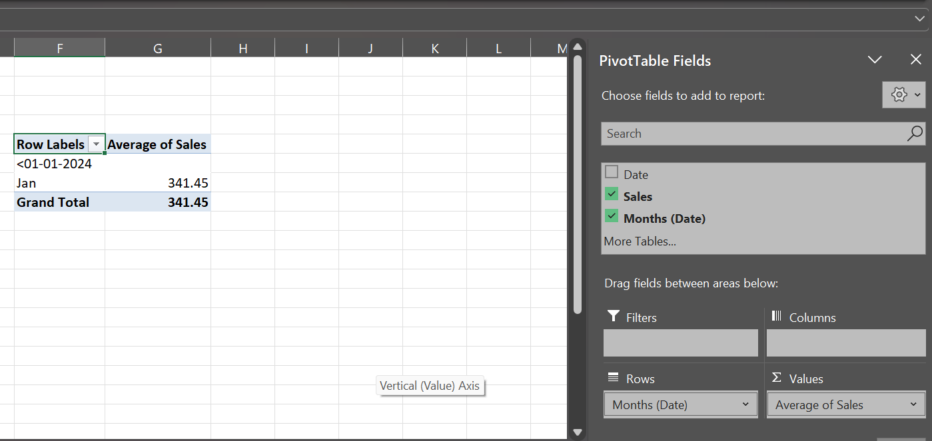
Q10. Combine Apples and Oranges into one group called Fruits and compare its sales with other products.
ANS: